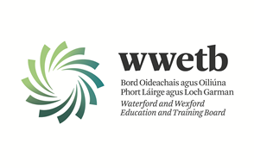

SPECIAL NEEDS ASSISTANT PANEL

**Permanent, Temporary, Full-time and Part-time Panel Positions in WWETB Schools**

Applications are invited from suitably qualified persons for inclusion on a SNA panel for the following schools under the patronage of Waterford and Wexford Education and Training Board (WWETB) in the following locations:

**Waterford**

Dungarvan College/ Coláiste Dhún Garbhán, St. Declans Community College, St. Pauls Community College, Meánscoil San Nioclás.

**Wexford**

Bridgetown College, Bunclody Community College, Coláiste Abbáin, Coláiste an Átha, Creagh College, Enniscorthy Community College, Gorey Hill School, Kennedy College, Kilnamanagh Community National School, Selskar College.

*Following interview, a panel of successful candidates will be formed to fill current and future SNA vacancies up to April 2026.*

**Essential Requirements for the Role:**

* Candidates must have a minimum QQI Level 3 major qualification on the National Framework of Qualifications or a minimum of three grade Ds in Junior Certificate or equivalent.

**Desirable Requirements for the Role:**

* Minimum 2 years previous experience as a SNA role in a school setting.
* Further relevant qualifications such as the FETAC Level 5/6 SNA Certificate and/or relevant third level qualification in a related field.
* To apply for Gorey Hill School previous experience of working in the special educational needs and/or disabilities sector is preferable.

Application form and full details may be obtained from <https://www.wwetb.ie/about/organisation/human-resources/vacancies/>  
Completed applications should be returned to [vacancies@wwetb.ie](mailto:vacancies@wwetb.ie) by **4:00pm on 09/05/2025**

WWETB is an equal opportunity employer.

Canvassing will disqualify.

Shortlisting may apply.

Late applications will not be accepted.

