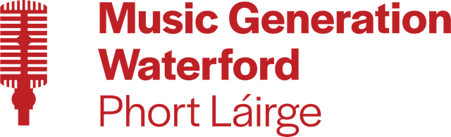

WATERFORD AND WEXFORD EDUCATION AND TRAINING BOARD

ADMINISTRATOR
MUSIC GENERATION WATERFORD
5 YEAR FIXED-TERM CONTRACT
FULL-TIME – 5 DAYS PER WEEK (35 HOURS PER WEEK)
MUSIC GENERATION WATERFORD – BASED IN DUNGARVAN, WATERFORD

WWETB, as Lead Partner for Music Generation Waterford, wishes to recruit an Administrator to assist the Music Generation Waterford Development Officer with the organisation, promotion and day-to-day running of Music Generation Waterford performance music education programme in Waterford City & County. The ideal candidate will have a relevant qualification, a passion for music in all its forms and for its promotion and development.

Details of post and application are available to download from:

https://www.wwetb.ie/vacancies

Notes:
- The closing date for receipt of applications is 4pm on Monday 21st April 2025
- Late or incomplete applications will not be considered
- Shortlisting may apply
- Garda Vetting will apply
- Canvassing will disqualify

WWETB/County Council is an Equal Opportunities Employer

