JOB DESCRIPTION
Competition Title: | Administrative Officer – FET Programme Development & Review Officer
Grade: | Grade VII
Reporting To: | Quality Manager
Tenure: | 2-year fixed term contract
Location: | Waterford Training Centre
Applications to: | By email to vacancies@wwetb.ie
Competition Profile: | This is an open competition.

Summary of Position
As part of the FET Quality Team, the Programme Development & Review Officer will lead the development of new FET programmes and curricula and manage the ongoing and systematic review of existing FET Programmes, including Programme Descriptors, Course Specifications and Assessment Instrument Specifications (AISs).

The successful candidate(s) will support the delivery of quality FET provision, taking a lead role in course and programme evaluations, blended programme development, tertiary programme development, recognition of prior learning (RPL) and integration of UDL. Further detail on the duties and responsibilities are outlined below.

Essential Requirements for Grade VII post holders
- Have the requisite knowledge, skills and competencies to carry out the role. Competencies will be informed by best practice Public Appointment Service competency frameworks for the Irish Public Service;
- Be capable and competent of fulfilling the role to a high standard;
- Have obtained at least Grade D3 in five subjects in the Leaving Certificate Examination (higher, ordinary, applied or vocational programmes) or equivalent or have passed an examination at the appropriate level within the QQI qualifications framework which can be assessed as being of a comparable to Leaving Certificate standard or equivalent or higher or have appropriate relevant experience which encompasses equivalent skills and expertise;

Desirable Criteria
- In depth knowledge of Quality Assurance, Further Education and Training provision.
- Knowledge of review processes, programme and curriculum design, and assessment.
- Broad based knowledge of education and training methodologies
- Knowledge of awarding body policies and procedures including QQI, C&G etc.
- Knowledge of Blended Learning, Tertiary, RPL and UDL
- Teaching/Training/Education experience desirable
- Teaching/Training/Education qualification desirable
- Good communication skills - both verbal and written
- MS Office skills (Word, excel, PowerPoint)
- Self-motivating, flexible and results focussed
- Ability to prioritise and manage work in a dynamic and fast paced environment
- Proven record as a team player
- Goal oriented in a manner that ensures work is comprehensively completed
- Ability to work on own initiative within a flexible, co-operative, team structure

Main Duties of the role
- Lead the development of new FET programmes and curricula, including Programme Descriptors, Course Specifications and Assessment Instrument Specifications (AISs).
- Review and update existing FET Programmes, including Programme Descriptors, Course Specifications and Assessment Instrument Specifications (AISs) as need arises.
- Assist the FET Leadership Team in the review and re-development of the WWETB Programme Development, Validation and Review Policy
- Collaborate in the development of a comprehensive cyclical review process for WWETB programmes to ensure their validity and quality
- Manage the formal review of WWETB programmes including systematic consultation with principal stakeholders:
  - Learners
  - Practitioners
  - Employers
  - Other Stakeholders such as NGOs, regulatory bodies, field of learning experts, etc
- Collate programme review information into programme update and development actions
- Coordinate submission of differential validation applications
- Assist with review of new apprenticeship curricula
- Participate in programme boards as required
- Formal review of existing programmes in respect of UDL for delivery and Assessment
- Assist with review of existing programmes in respect of RPL for entry and RPL for certification
- Participate in the Mentor Process for RPL for entry and RPL for certification
- Support centres and coordinators on the development of programmes in terms of blended learning delivery as per WWETB Blended learning policy
- Keep abreast of programme development activity at a national level and liaise with other ETBs with regard to:
  - Partnering for programme development
  - Differential Validation
  - Broader programme review activities
  - Developments in QQI Award Standards and the validation process
- Liaise with other award bodies with regard to award and programme review
- Assist with Tertiary programme development in collaboration with the WWETB Tertiary Manager, HE institutions and the NTO.
- Manage the review of WWETB FET Work Experience Procedures and work experience modules
- Produce Monthly report for FET Management Team on status of Programme development activity and programme review activity
- Assist the FET Management Team with actions related to provision planning
- Report to Quality Manager and Director of FET and carry out any tasks that may need action at the discretion of the Quality Manager and/or the Director of FET
- Participate on the WWETB Teaching Learning and Assessment Network
- Participate on the WWETB Quality Assurance Steering Group
- Input on Programme Approval process both as part of the QASG and as support for centres for Programme Approval (PAC) applications
- Collaborate with all levels of management as required to enhance programmatic offerings and liaise with key stakeholders to establish need and opportunity for provision
- Liaise with relevant colleagues to ensure provision of timely and accurate information for prospectus and website
- Act as the Facilitator for Recognition of Prior Learning requests for FET provision. Lead RPL projects locally. Participate, co-lead in review of formal RPL process
- Undertake any other duties as assigned by Quality Manager or Director of FET.

Salary
Salary will be paid in accordance with such rates as may be authorised by the Minister for Education
from time to time for Grade VII positions.

Entry point to this scale will be determined in accordance with Circulars issued by the Department of Education. Rate of remuneration may be adjusted from time to time in line with Government Policy. Please refer to https://www.wwetb.ie/about/organisation/human-resources/pay/ for current salary scale. Successful candidates will be paid at point 01 of the salary scale unless they have previous relevant public sector service in experience.
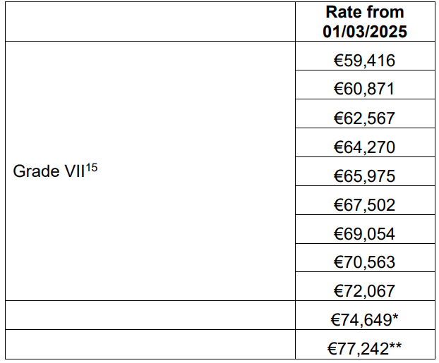
Application Form
Applications must be made on the official Administrative Officer Application Form and all sections must be completed in full. When completing the application form accuracy is essential as the information supplied in the form will play a central part in the selection process. Applications can be accessed via: https://www.wwetb.ie/about/organisation/human-resources/vacancies/
Shortlisting
WWETB is an Equal Opportunities Employer. WWETB reserves its right to shortlist candidates, in the manner it deems most appropriate, to proceed to the interview stage of the competition. Shortlisting will be on the basis of information supplied on the Application Form and the likely number of vacancies to be filled. It is therefore in your own interest to provide a detailed and accurate account of your qualifications/experience on the application form. The shortlisting process will provide for the assessment of each applicant’s application form against predetermined criteria that reflect the skills and depth of experience considered to be essential for a position at this level. Canvassing will automatically disqualify.
Interview
Selection, from shortlisted candidates, shall be by means of a competition based on an interview conducted by WWETB. WWETB Core Values of Respect, Accountability, Learner Focus, Quality and Sustainability are the guiding principles of the organisation and underpin the competencies required to fulfil this role. The interview will be competency based and marks will be awarded under the following Core Competencies identified for the position of Administrative Officer Grade VII:
- Team Leadership
- Analysis and Decision Making
- Management and Delivery of Results
- Interpersonal and Communication Skills
- Specialist Knowledge, Expertise and Self Development
- Drive and Commitment to Public Service Values

These core competencies are assessed and awarded marks by demonstrating the following key skills sets:

Team Leadership
- Works with the team to facilitate high performance, developing clear and realistic objectives and addressing any performance issues if they arise
- Provides clear information and advice as to what is required of the team
- Strives to develop and implement new ways of working effectively to meet objectives
- Leads the team by example, coaching and supporting individuals as required
- Places high importance on staff development, training and maximising skills and capacity of team
- Is flexible and willing to adapt, positively contributing to the implementation of change

Analysis and Decision Making
- Gathers and analyses information from relevant sources, whether financial, numerical or otherwise weighing up a range of critical factors
- Takes account of any broader issues and related implications when making decisions
- Uses previous knowledge and experience in order to guide decisions
- Makes sound decisions with a well reasoned rationale and stands by these
- Puts forward solutions to address problems

Management and Delivery of Results
- Takes responsibility and is accountable for the delivery of agreed objectives
- Successfully manages a range of different projects and work activities at the same time
- Structures and organises their own and others work effectively
- Is logical and pragmatic in approach, delivering the best possible results with the resources available
- Delegates work effectively, providing clear information and evidence as to what is required
- Proactively identifies areas for improvement and develops practical suggestions for their implementation
- Demonstrates enthusiasm for new developments/changing work practices and strives to implement these changes effectively
- Applies appropriate systems/processes to enable quality checking of all activities and outputs
- Practices and promotes a strong focus on delivering high quality customer service, for internal and external customers

Interpersonal and Communication Skills
- Builds and maintains contact with colleagues and other stakeholders to assist in performing role
- Acts as an effective link between staff and senior management
- Encourages open and constructive discussions around work issues
- Projects conviction, gaining buy-in by outlining relevant information and selling the benefits
- Treats others with diplomacy, tact, courtesy and respect, even in challenging circumstances
- Presents information clearly, concisely and confidently when speaking and in writing

Specialist Knowledge, Expertise and Self Development
- Has a clear understanding of the roles, objectives and targets of self and team and how they fit into the work of the unit and Department/Organisation and effectively communicates this to others
- Has high levels of expertise and broad Public Sector knowledge relevant to his/her area of work
- Focuses on self-development, striving to improve performance

Drive and Commitment to Public Service Values
- Strives to perform at a high level, investing significant energy to achieve agreed objectives
- Demonstrates resilience in the face of challenging circumstances and high demands
- Is personally trustworthy and can be relied upon
- Ensures that customers are at the heart of all services provided
- Upholds high standards of honest, ethics and integrity

Additional Information
Citizenship
- Candidates should note that eligibility to compete for posts is open to citizens of the European Economic Area (EEA) or to non-EEA nationals with a valid work permit. The EEA consists of Member States of the European Union along with Iceland, Liechtenstein and Norway.
- Swiss citizens under EU agreements may also apply.

Health & Character
- Those under consideration for a position may at the discretion of the employer be required to complete a health and character declaration and a Garda Vetting form.
- References will be sought.
- Canvassing will disqualify.
- Some posts require special security clearance.
- In the event of potential conflicts of interest, candidates may not be considered for certain posts.

