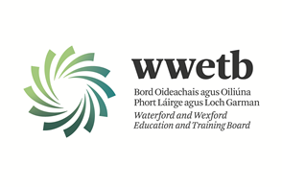

Applications are invited from suitably qualified persons for the following vacancy:

**ADMINISTRATIVE OFFICER (GVII)**

**FET PROGRAMME DEVELOPMENT AND REVIEW OFFICER**

**2 YEAR FIXED-TERM CONTRACT**

**LOCATION – WATERFORD TRAINING CENTRE**

**35 HOURS PER WEEK**

**This is an open competition.**

All details including Application form and a detailed Job Description can be downloaded from our website:

[**https://wwetb.ie/about/organisation/human-resources/vacancies**](https://wwetb.ie/about/organisation/human-resources/vacancies/)

Completed application forms should be submitted to [vacancies@wwetb.ie](mailto:vacancies@wwetb.ie)

by **4:00pm on Friday 4th April 2025**

Short Listing may apply.

Canvassing by or on behalf of the candidate will automatically disqualify.

Late applications will not be accepted.

WWETB is an equal opportunities employer.

