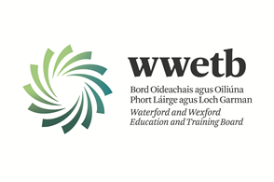

YOUTH WORK AFFAIRS - WEXFORD

Applications are invited from suitably qualified persons for the following:

CLERICAL OFFICER (GRADE III) – YOUTH WORK AFFAIRS
PERMANENT CONTRACT
PART TIME POSITION – 17.5 HOURS PER WEEK OVER 3 DAYS

INITIAL LOCATION: WWETB HEAD OFFICE, ARDCAVAN, WEXFORD

OPEN COMPETITION

All details including Application form and a detailed Job Description can be downloaded from our website:

https://www.wwetb.ie/about/organisation/human-resources/vacancies/

Completed application forms should be emailed to vacancies@wwetb.ie by Friday 18th April 2025 at 4pm.

WWETB is an equal opportunity employer.
Canvassing will disqualify.
Shortlisting may apply.
Late applications will not be accepted.

