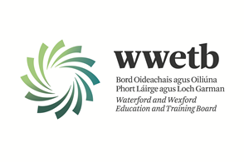

Applications are invited from suitably qualified persons for the following:

YOUTHREACH RESOURCE PERSON - GOREY

SPECIFIC PURPOSE CONTRACT COVERING A MATERNITY LEAVE UNTIL APPROXIMATEY OCTOBER 2025

35 HOURS PER WEEK

**Modules to be delivered include:**

Communications QQI 4

English & Communication

Application form and full details may be obtained from <https://www.wwetb.ie/about/organisation/human-resources/vacancies/>

Completed applications should be returned to [vacancies@wwetb.ie](mailto:vacancies@wwetb.ie) by

**4:00pm on Wednesday 19th February 2025.**

Shortlisting may apply.

Canvassing by or on behalf of the candidate will automatically disqualify.

Late applications will not be accepted.

All appointments are subject to the sanction of the Minister for Education.

WWETB is an equal opportunities employer.

