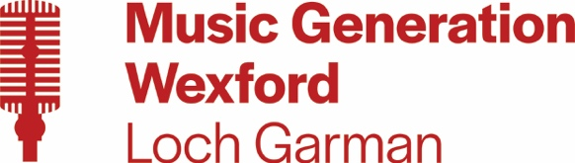

WATERFORD AND WEXFORD EDUCATION AND TRAINING BOARD

ADMINISTRATOR
SPECIFIC PURPOSE CONTRACT
PART-TIME – 3 DAYS PER WEEK (24 HOURS PER WEEK)
MUSIC GENERATION WEXFORD – BASED IN ARDCAVAN, WEXFORD

WWETB, as Lead Partner for Music Generation Wexford, wishes to recruit an Administrator to assist the Music Generation Development Officer with the organisation, promotion and day-to-day running of Music Generation performance music education programmes in Wexford County. The ideal candidate will have a relevant qualification, a passion for music in all its forms and for its promotion and development.

Details of post and application are available to download from www.wwetb.ie

Notes:
- The closing date for receipt of online applications is 4pm on 5th February 2025
- Late or incomplete applications will not be considered
- Shortlisting may apply
- Garda Vetting will apply
- Canvassing will disqualify

WWETB/County Council is an Equal Opportunities Employer

