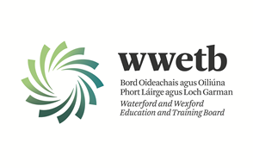

Applications are invited from suitably qualified persons for the following:

YOUTHREACH RESOURCE PERSON - GOREY

PERMANENT CONTRACT – 17.5 HOURS PER WEEK

**Modules to be delivered include:**

Literacy & Numeracy Support

Hair & Beauty

Application form and full details may be obtained from <https://www.wwetb.ie/about/organisation/human-resources/vacancies/>

Completed applications should be returned to [vacancies@wwetb.ie](mailto:vacancies@wwetb.ie) by

**4:00pm on Wednesday 29th January 2025.**

Shortlisting may apply.

Canvassing by or on behalf of the candidate will automatically disqualify.

Late applications will not be accepted.

All appointments are subject to the sanction of the Minister for Education.

WWETB is an equal opportunities employer.

