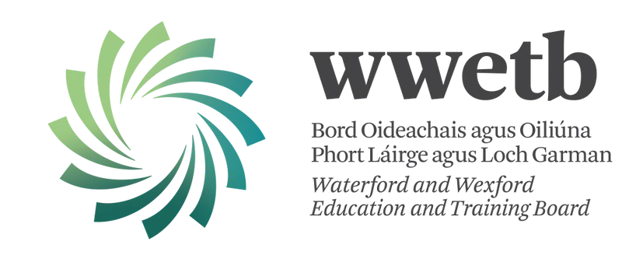WWETB

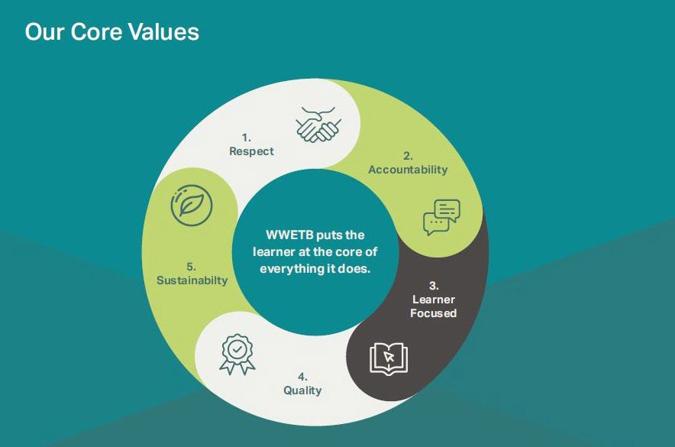

Human Rights and Equality Public Sector Duty Progress Report May 2024



**Web Accessibility Directive Accessibility Statement Published**

**Interactive Diversity Calendar 2024 launched**

**750 staff are trained in Technology Enhanced Learning (TEL) and Assistive Technologies.**

**TEL delivered training and 1:1 support focused on accessibility and inclusivity, in schools and centers. Learning Accelerators in Microsoft 365 - Reading Progress and Coach for Reading Fluency. Search Progress and Coach for Information Literacy.**

Gender Pay Gap Report and Statement published. Launch of the WWETB Rainbow Connection Initiative, a project supporting LGBTQI+ staff and learners across all sections. 89 staff have achieved the Rainbow Badge.

Cross-representative staff working groups commenced to execute the WWETB Strategy Statement for 2023-27.

Support and funding were provided to 254 Community Education groups in 2023, encompassing community groups representing individuals protected under the 9 grounds.

Music Generation engaged over 9000 children and young people across the region with over 8000 instruments on loan.

41 staff participated in SETU ‘Enhancing Equality, Diversity and Inclusion’ in Further Education and Training (FET) Masterclass series’ for WWETB.

LGBTQI+ awareness Staff Training delivered to 70 staff Plain English Training delivered to 30+ Staff

15 staff attended Dyslexia Training

60 staff have achieved the Universal Design for Learning Badge in 2023

60 staff attended Autism Acceptance and Understanding Workshop delivered by AsIam

34 staff attended Practical Strategies for Teaching Autistic Students in Further Education Training delivered by AsIam 28 staff attended How to Support Autistic Students in Work Placements and in Work Based Learning Training delivered by AsIam, webinars posted to the staff hub

49 staff participated in Disability Awareness Training delivered by Ability Focus

Active Consent Awareness Training delivered to 86 staff 24 staff received Active Consent Facilitator Training

4 Staff representing on the Active Consent Advisory Group Over 250 learners have attended Active Consent workshops

Mapping of all buildings, including size and capacity, has been completed with a plan to conduct Disability Audits on two main campuses in 2024

Sensory spaces are being introduced across FET Centres and Colleges.

QA established the Teaching, Learning, and Assessment Working Group for FET with Universal Design for Learning (UDL) as the chosen theme for 23/24.

Participated in Amber’s One Million Stars Ireland inclusive community arts project in solidarity against domestic abuse and all forms of violence.

Spectrum Life Employee Assistance Service (EAS), a confidential counselling service that provides staff support.

In the process of achieving KeepWell Mark™ from Ibec Working with The Irish Centre for Diversity to achieve Bronze Investors in Diversity Accreditation

Working with AsIam to achieve Sensory Friendly Accreditation for the new Wexford College of FET Each post-primary college engaging in a Provision Mapping Initiative. All 12 colleges have now carried out a whole staff workshop to identify and evaluate the supports available to students.

FET central Learner Support Service was established under 3 streams: Disability Support, Academic Support, and Mental Health and Wellbeing

Introduced 24/7 mental health and wellbeing support for FET learners

Speak Easy counselling and one-to-one support for Apprentices and FET Learners available

FET Learner Support Tutor Panel was established 104 learners attended the FET Learner Voice Forum WWETB internal FET Learner Council established - 23 members

Learners as Leaders training programme delivered to 15 FET learners

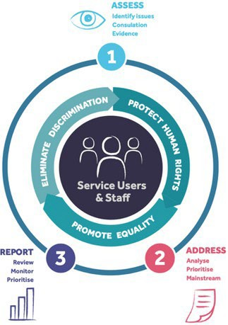The Public Sector Duty is a legal obligation on public bodies, contained in Section 42 of the Irish Human Rights and Equality Commission Act 2014



[**https://www.wwetb.ie/**](https://www.wwetb.ie/public-sector-equality-and-human-rights/)