WATERFORD & WEXFORD EDUCATION & TRAINING BOARD (WWETB)

MUSICIAN EDUCATORS
MUSIC GENERATION WATERFORD & MUSIC GENERATION WEXFORD

Waterford and Wexford Education and Training Board, as Lead Partner for Music Generation Waterford & Wexford, now wishes to recruit suitably qualified and experienced musician educators to add to a panel of musician educators to deliver the following programme strands:

- Small-group performance music education in traditional Irish instruments/pop and rock/classical strings and singing in after-school community settings
- Small-group performance music education in vocal (including choral) or instrumental learning in any music genre in after-school community settings
- Large-group performance music education (vocal and/or instrumental) primary school settings
- Ensemble - Band Lead/Mentor multiple genres & styles

Details of post and application are available to download from Other Vacancies - Waterford and Wexford Education and Training Board (wwetb.ie)

Notes:
Completed applications should be submitted to vacancies@wwetb.ie
by 4pm on Friday 19th July 2024.

Late or incomplete applications will not be considered
Shortlisting may apply
Garda Vetting will apply
Canvassing will disqualify

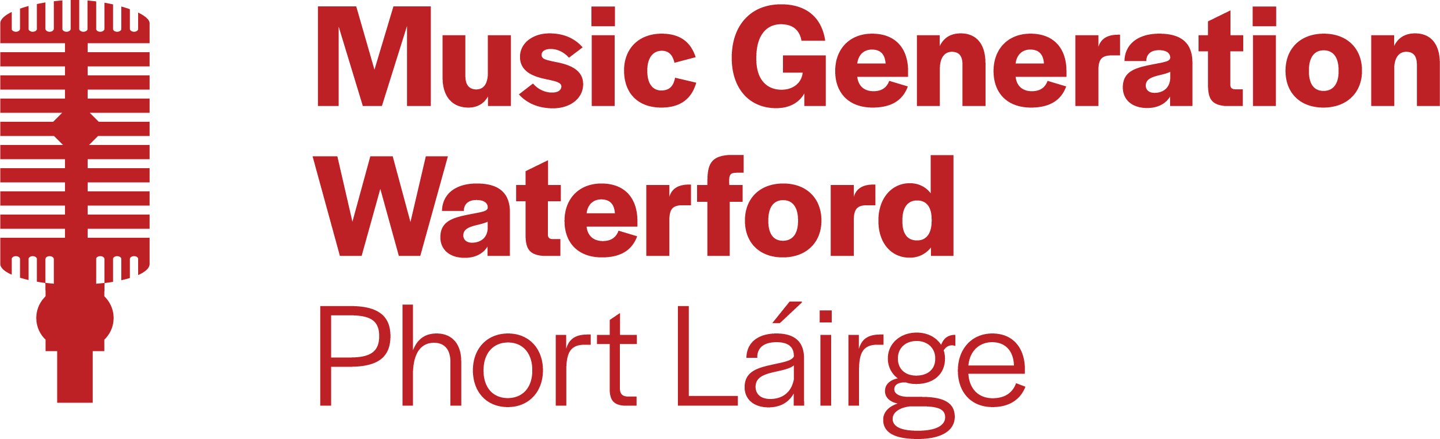
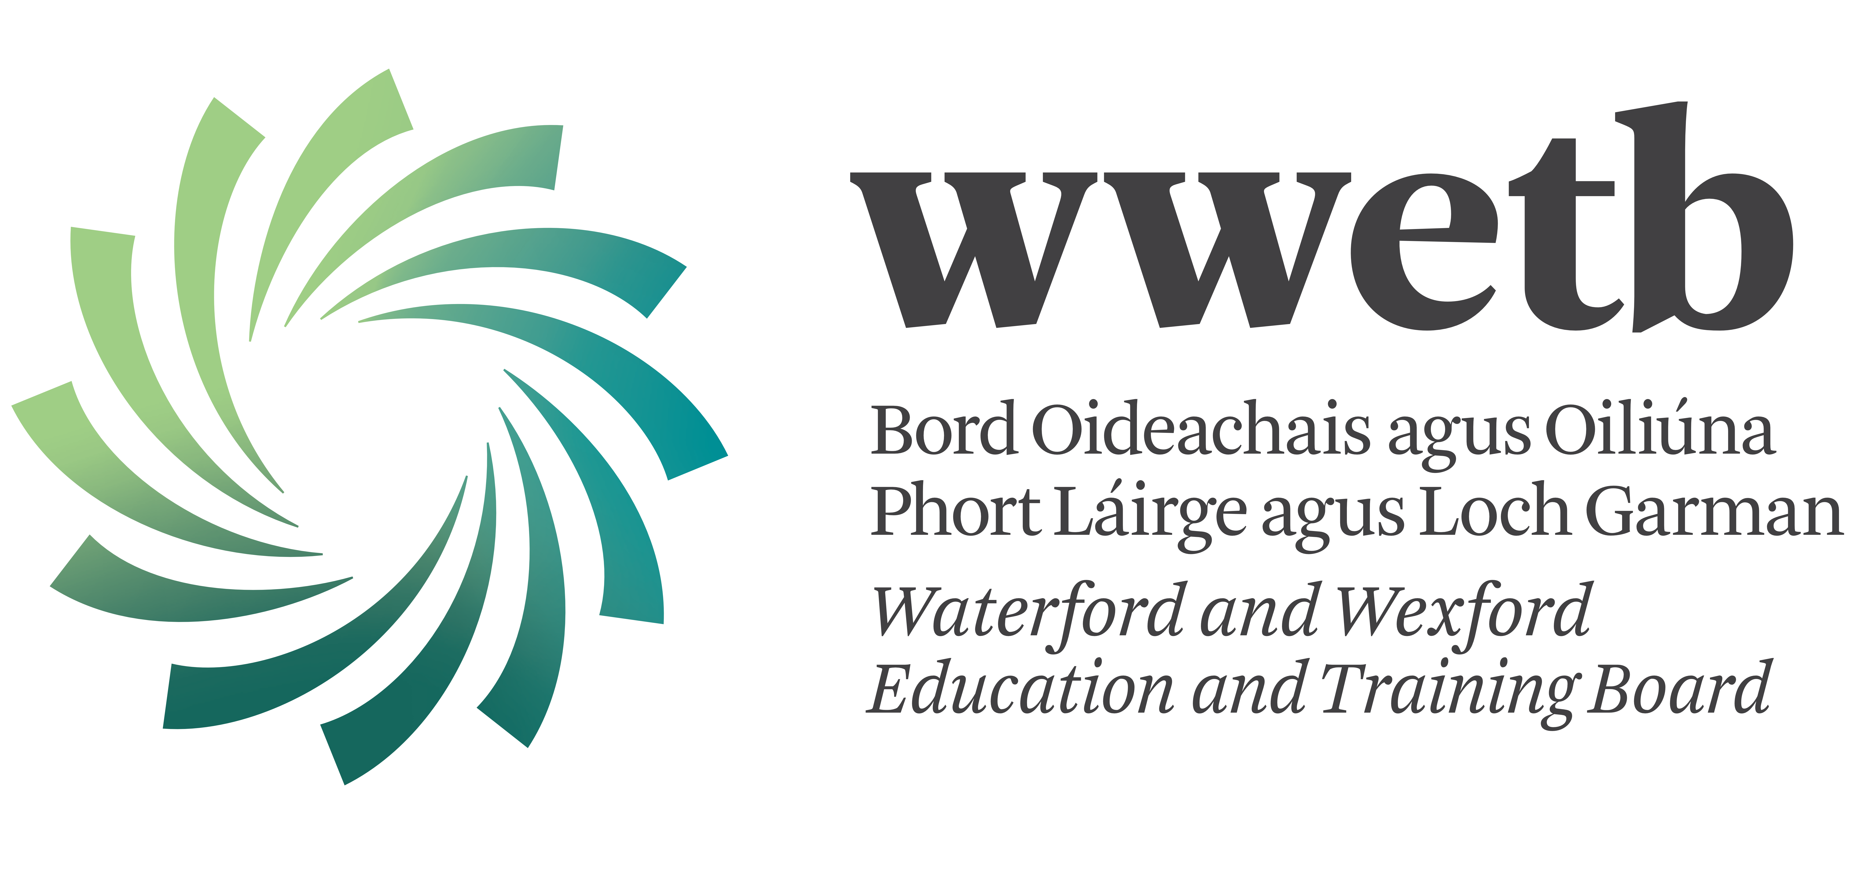
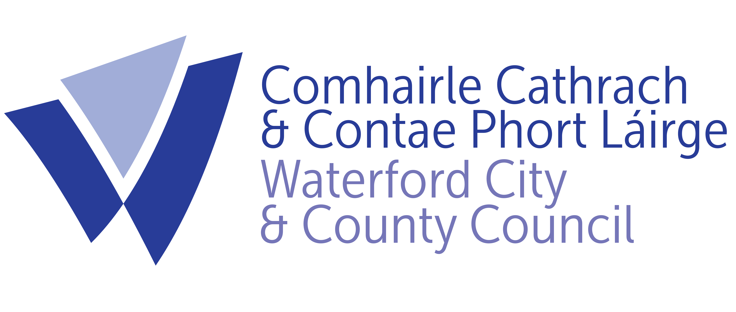
Musician Educators work with children and young people in group contexts and may be asked to work on one or more programmes at any given time.

To find out more about Music Generation visit: www.musicgeneration.ie or visit Music Generation Waterford and Wexford media platforms; Facebook, Instagram, Twitter, Youtube.

